

**UNIVERSITY OF PETROLEUM AND ENERGY STUDIES**

**School of Computer** **Science**

**2020-21**

**GRAPHICS AND ANIMATION TOOLS LAB**

**Faculty: Dr. DURGANSH SHARMA**

**Assistant Professor**

**Department of Cybernetics.**

**School of Computer Science, UPES**

**Submitted By:**

**Name- Vartika Deep**

**Roll no-R100217088**

**Batch-B3**

**Semester- 7**

**Course-B.tech. CSE-OSOS**

**Sap Id- 500062441**

**VIVA-1**

**Spectacles**

**STEPS:**

1.Download a spectacles image from internet.

2.In gimp open the downloaded image as, Open as Layers.

3.Select free select tool and perform image tracing of the left glasses first.

4.Colour the glass as per your choice.

5.Repeat step 2 from the glass frame and color the glass.

6.Create duplicate layer of glass and go to layers – transform - flip horizontally.

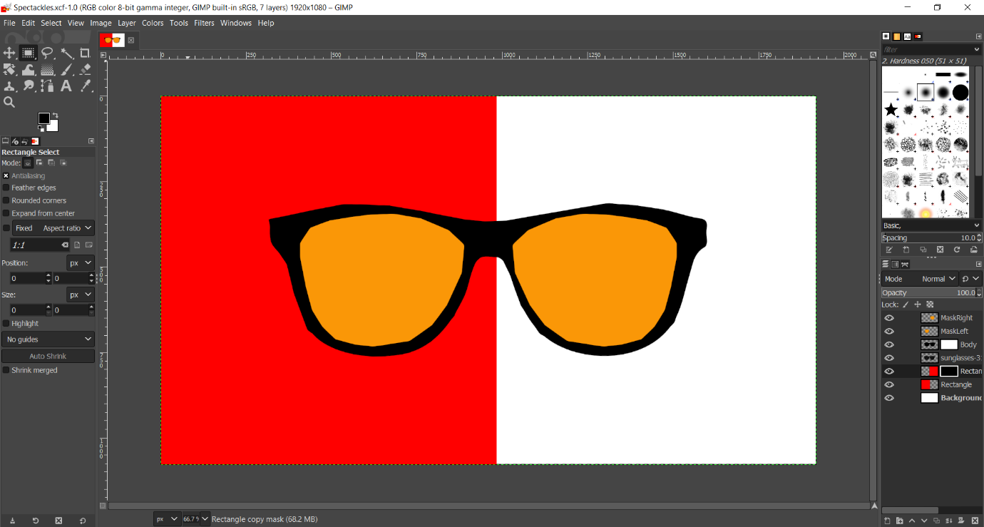

**2.Laptop**

1.Add plane and scale it. Select the plane and extrude it.

2.Create a loop cut and extrude it to make the screen of the laptop.

3.Make many loop cuts to and extrude them to make the keys of the keyboard.

4.Make another loop cut to create the mouse.

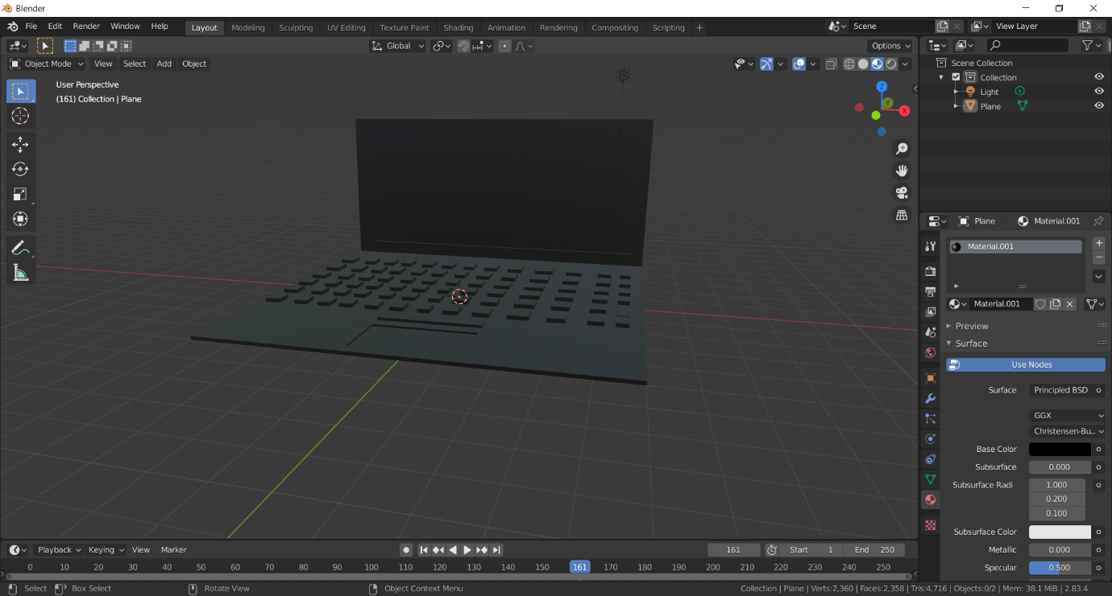

Link:

https://drive.google.com/drive/folders/13zX7kyR4mc0X5gh4aJI3on_38d_fPOrY?usp=sharing